# CS 255 System Design Document Template

This template lays out all the different sections that you need to complete for Project Two. Each section has guidance to prompt your thinking. You will need to continually reference the interview transcript as you work to make sure that you are addressing your client’s needs. There is no required length for the final document. Instead the goal is to complete each section based on what your client’s needs are. Remove this note when you are finished, and replace all bracketed text with the relevant information.

## UML Diagrams

### UML Use Case Diagram

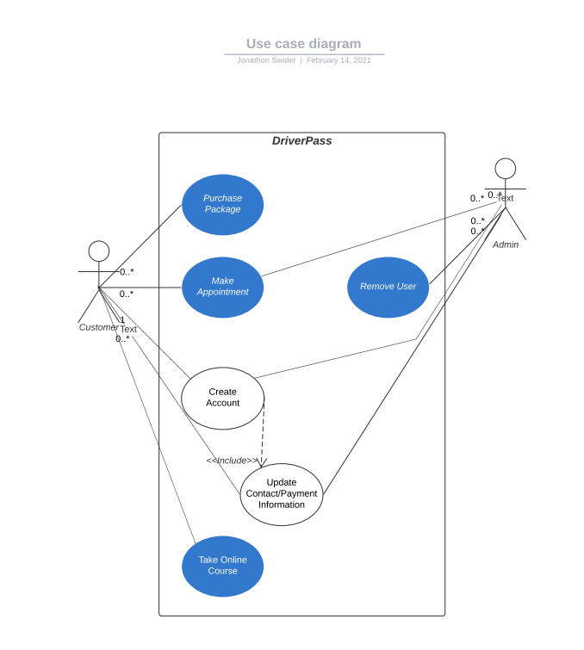

### UML Activity Diagrams

### 

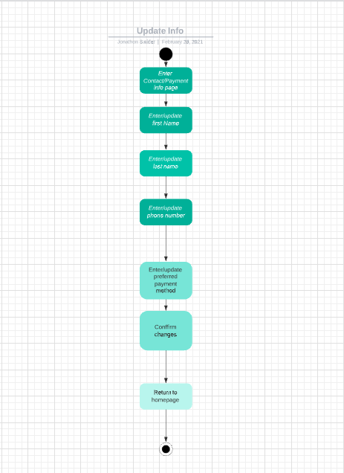

### UML Sequence Diagram

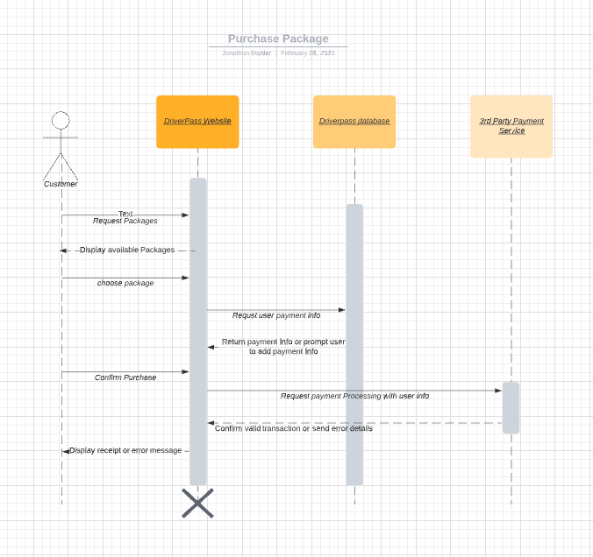

### UML Class Diagram

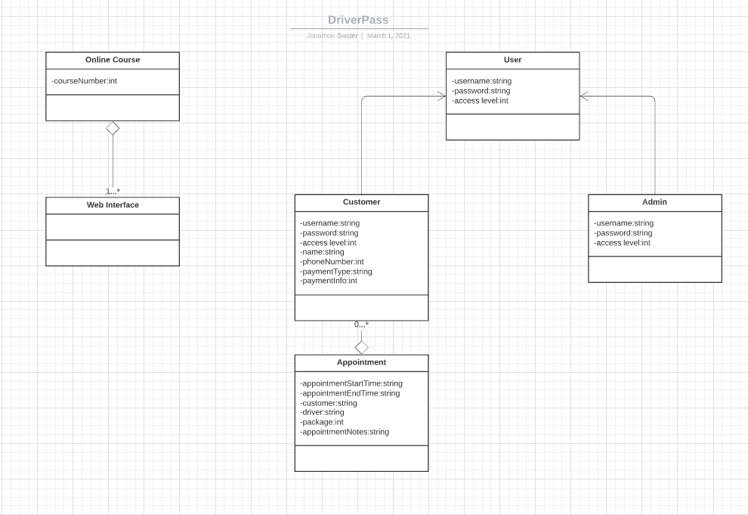

## Technical Requirements

This system is designed to be cloud based so there are no in house hardware requirements, however the system requires a database for user credential validation, customer records and online course learning material. Additionally the system relies on the user of a third party service to process payments. The web interface needs to be designed with compatibility in mind to support all major web browsers as well as mobile users.